Gypsy Soul

2018

biography
After wandering the earth for over a decade she finds him full of soul amongst a killer jam session. Natasha Hardiman and Patrick Gill are the back bone of the band Gypsy Soldiers, both based in Mackay they met all current members of the band at one of the many thriving jam sessions in the Mackay region.
Gypsy Soul have been together now for 6 years and they are regular entertainers on the Mackay, Whitsundays and Bowen Music scene.
They specialize in Weddings and corporate functions, playing lots of events where they may need to start with intimate dinner music and finish with party sets to cross all generations.
They are masters of audience engagement and play all requests thrown at us. They love all genres of music and play to the audience adding some comedy and theatrics to keep the audience guessing.
Pat and Tash are big supporters of local original music scene in the region.
They are also founding members of the Gypsy Soldiers band which fluctuate from a duo to a 6 piece band bringing together their own unique talents and authentic sound. A great party band with energetic, tight, heart thumping sound with theatrics to connect with every audience.
With a mixture of many different influences they find their sound is constantly changing. They love the classics.
They love to play covers putting their own twist on them and have many originals written from a collaboration of life experiences.
In 2017 the band recorded their first EP Paper dreams https://www.youtube.com/watch?v=ZlO4EgpzWAI&list=PLxXPqaMFAlE9afQ9q1NPF4XPiK0T20jvH
The bands original music can be likened to Kings of Leon, Rolling Stones, Janis Joplin. Acoustic goodness on the first EP and they are now migrating to electric. Their music crosses over genres and generations with the audience being able to relate to the lyrics and music.

The Gypsy Soldiers were front and centre on the main stage at the Airlie Beach festival of music with a 7 piece band, sharing the stage with Shannon Noll, Sneaky Sound System, Kate Cebrano, Glen Mattlock from the Sex Pistols and Leo Sayer, They have supported other great talents such as Ross Wilson, and the Black Sorrows. Also in 2017 they played Winton outback festival as well as NQ Bikes, Bulls and Buggies, Mackay Beach Horse Races, Bowen Fishing Classic and many other events and parties around the Mackay region.

Patrick Gill shreds on guitar with melodic riffs and his rhythmic tones will set you on fire. A vocal range starting way down in his boots and finishing in a strong falsetto.
Natasha Hardiman on vocals sings with attitude and all her heart and soul she also plays guitar and percussion.
This is our duo set up and we add the other members.
James Neill on drums lays down the beats with a flamboyant style and adds captivating vocal harmonies.
Allan Doherty on harmonica plays with powerful precision and is a master of his tone.
Jason Johns on bass makes the bass truly sing and you can’t help but groove to the beat.
Viviana Mamour brings energy to the stage with her recorder solo and gorgeous back vocals.

GYpsy Soul

MEDIA LINKS

https://www.facebook.com/patntash/
https://www.gypsysoul.rocks
https://www.instagram.com/gypsysoulband/

Click below for some live video footage
https://www.facebook.com/100007802178477/videos/2056451947958191/UzpfSTIzMTMzMTIwNzA0NjU5Nzo5NzczNDYwNDI0NDUxMDY/
https://www.facebook.com/100007802178477/videos/2057553891181330/UzpfSTIzMTMzMTIwNzA0NjU5Nzo5Nzg3NTM3Nzg5NzA5OTk/
https://www.facebook.com/100007802178477/videos/2056686661268053/UzpfSTIzMTMzMTIwNzA0NjU5Nzo5NzgxMTE2NDIzNjg1NDY/

Promotional photos
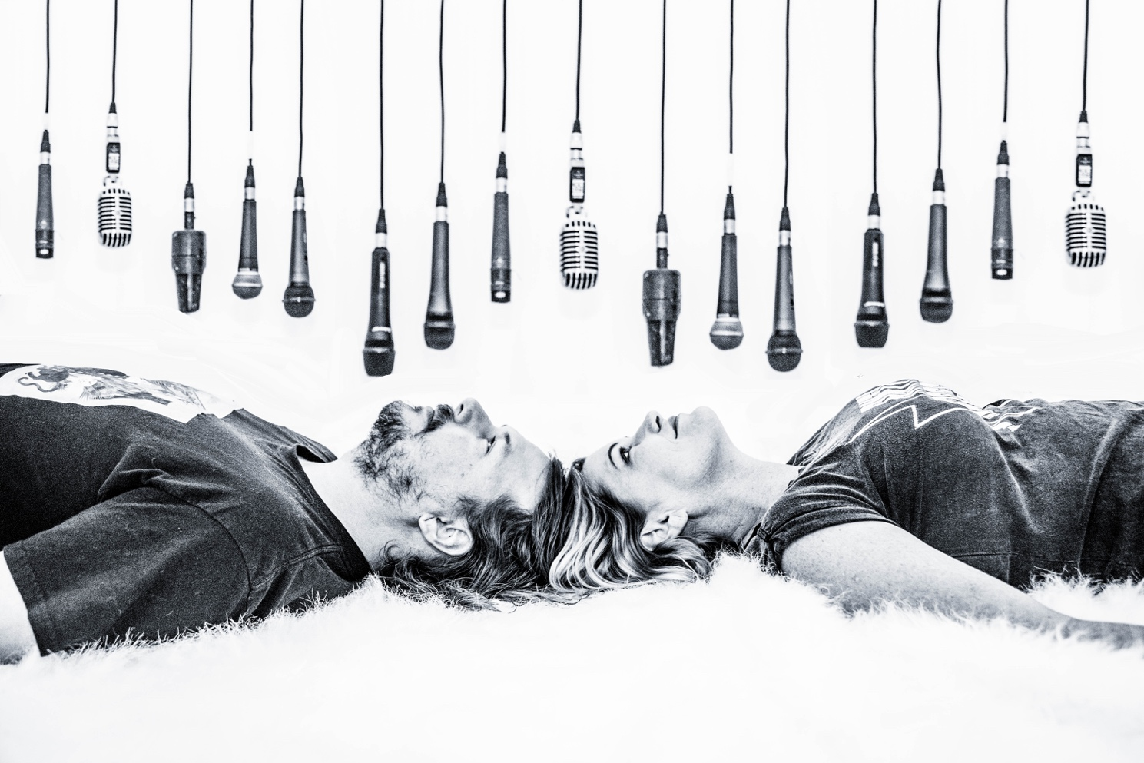
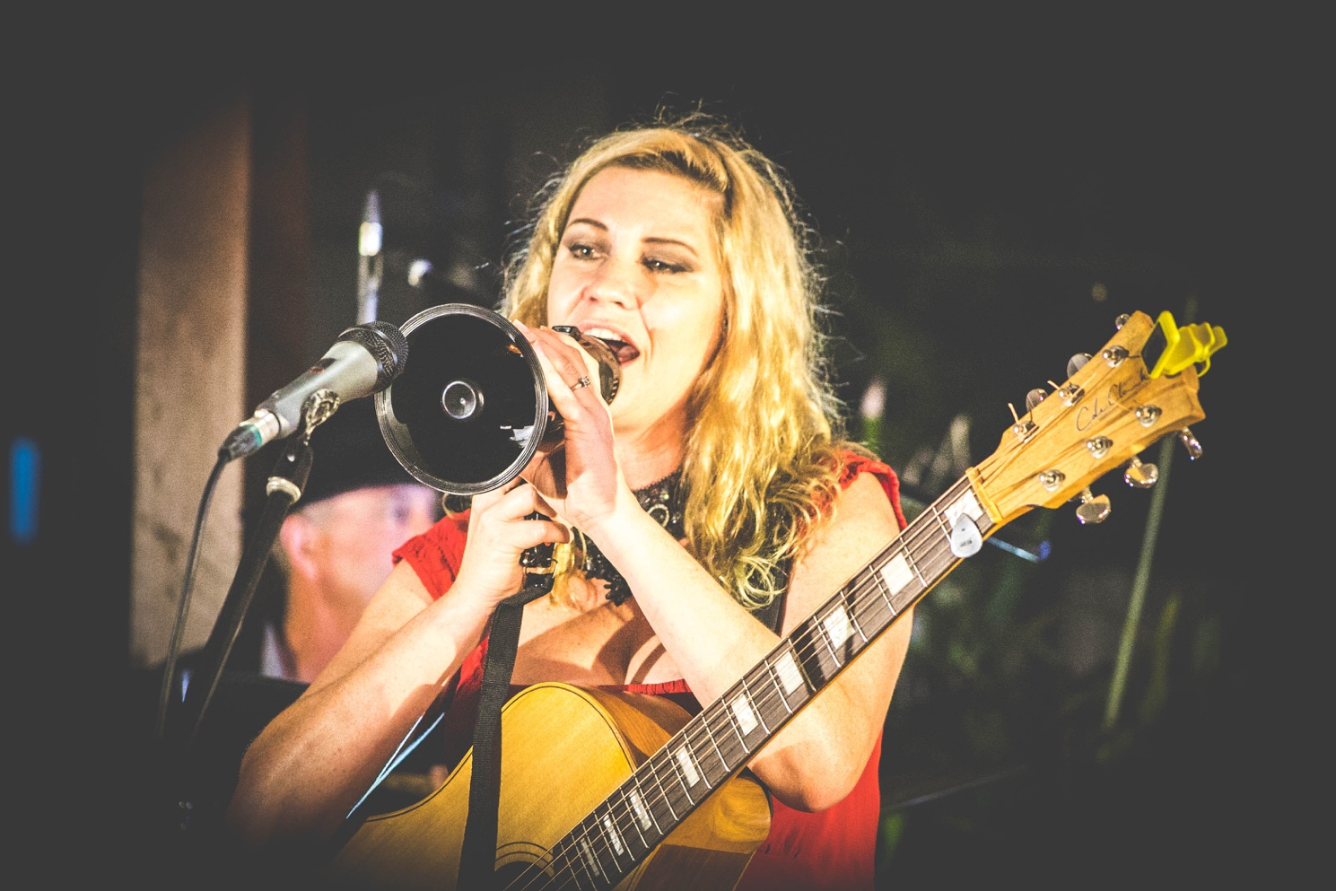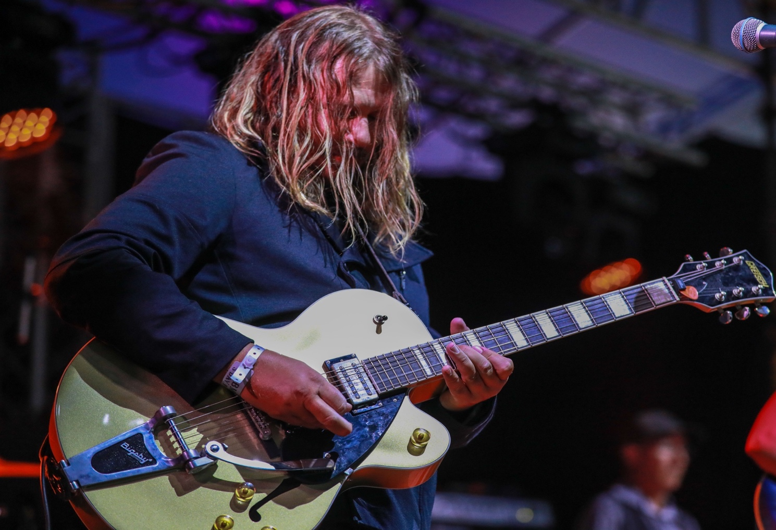
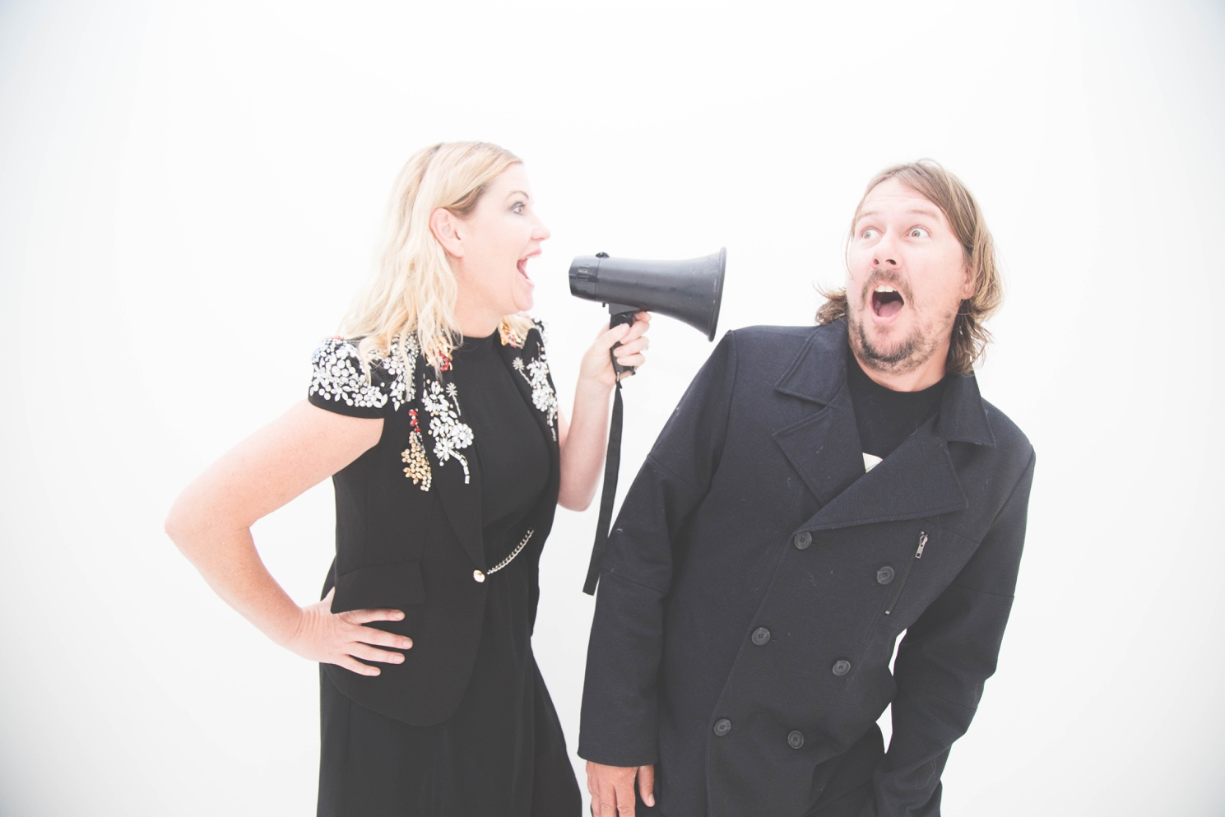

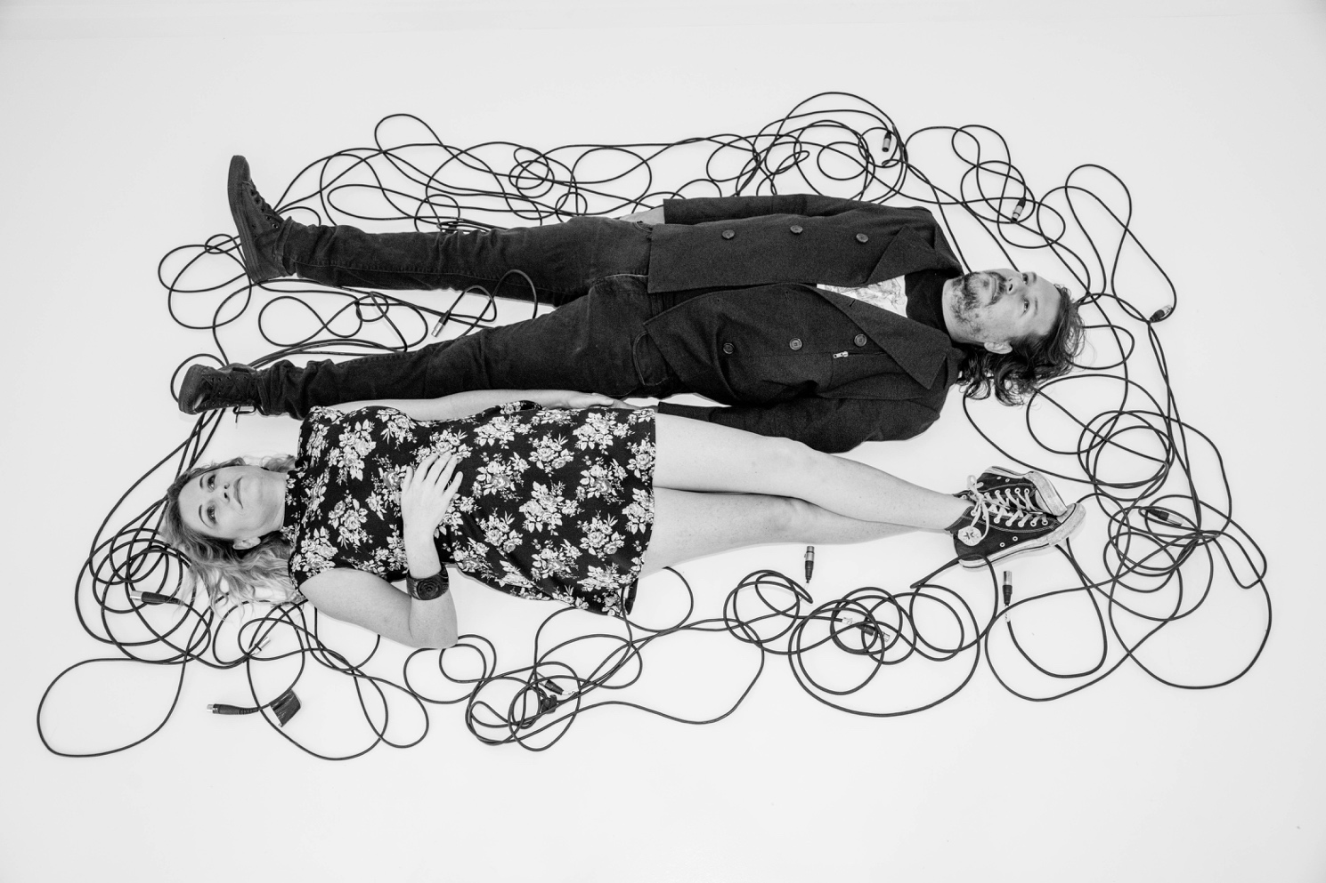
Specs we require to play as a Duo
3 x DI inputs – 2 guitars 1 Stomp
3 x mic inputs – 2 vocal mic’s and 1 for percussion
Thank you
Any further queries contact: Natasha Hardiman 0419110343
natashahardiman@gmail.com
